**BGP Exploration Lab**

**Task 1: Building a stub autonomous system**

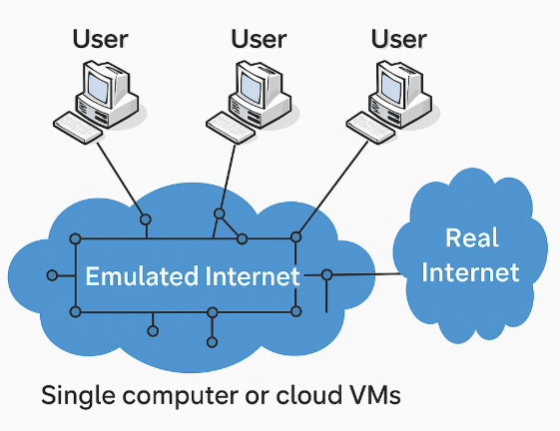

**Create the base layer and exchanges**

base = Base()

base.createInternetExchange(100)

base.createInternetExchange(101)

**Create stub autonomous systems**

as151 = base.createAutonomousSystem(151)

# Create an internal network

as151.createNetwork('net0')

# Create a host and attach it to the network

as151.createHost('host0').joinNetwork('net0')

# Create a router and attach it to two networks

as151.createRouter('router0').joinNetwork('net0').joinNetwork('ix100')

**Create a transit autonomous system**

as2 = base.createAutonomousSystem(2)

# Create 3 internal networks

as2.createNetwork('net0')

as2.createNetwork('net1')

as2.createNetwork('net2')

# Create four routers and attach them to networks.

# ix100 <--> r1 <--> r2 <--> r3 <--> r4 <--> ix101

as2.createRouter('r1').joinNetwork('net0').joinNetwork('ix100')

as2.createRouter('r2').joinNetwork('net0').joinNetwork('net1')

as2.createRouter('r3').joinNetwork('net1').joinNetwork('net2')

as2.createRouter('r4').joinNetwork('net2').joinNetwork('ix101')

**Create an Ebgp layer and Conduct BGP Peering**

ebgp = Ebgp()

# Peer AS-2 with ASes 151, 152, and 153 (AS-2 is the Internet service provider)

ebgp.addPrivatePeering(100, 2, 151, abRelationship = PeerRelationship.Provider)

ebgp.addPrivatePeering(101, 2, 152, abRelationship = PeerRelationship.Provider)

ebgp.addPrivatePeering(101, 2, 153, abRelationship = PeerRelationship.Provider)

# Peer AS-152 and AS-153 (as equal peers for mutual benefit)

ebgp.addPrivatePeering(101, 152, 153, abRelationship = PeerRelationship.Peer)

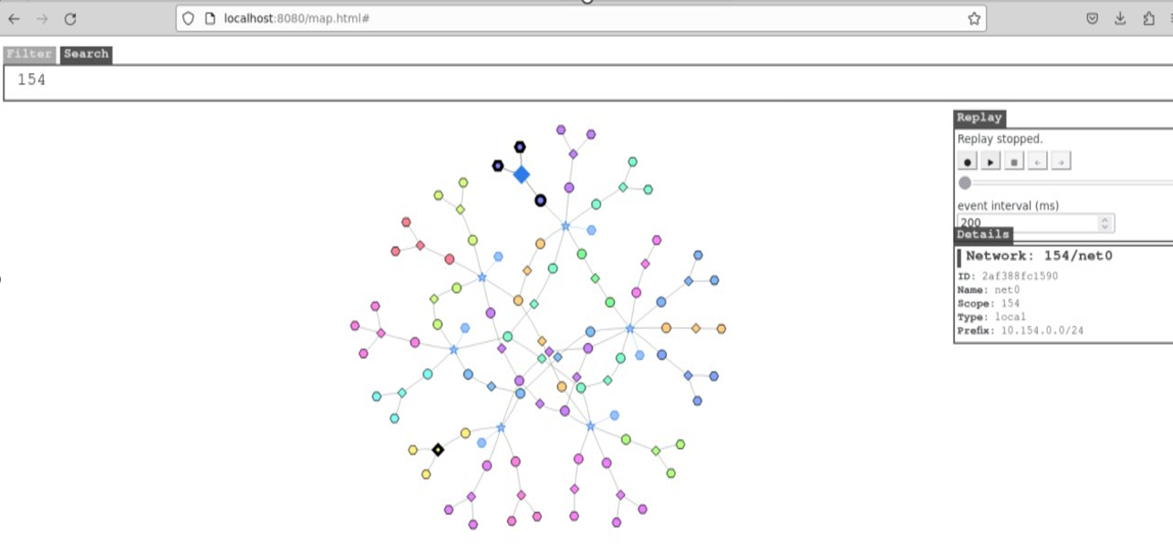

These are list of folders for each docker file

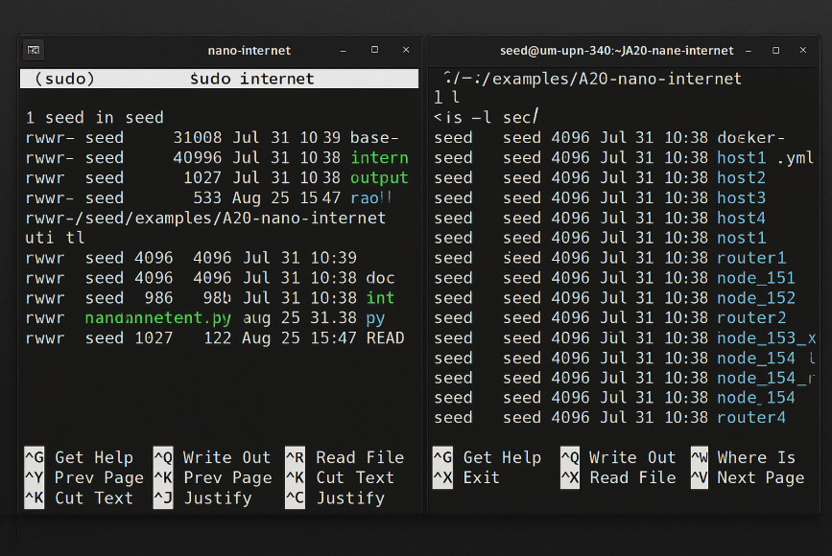

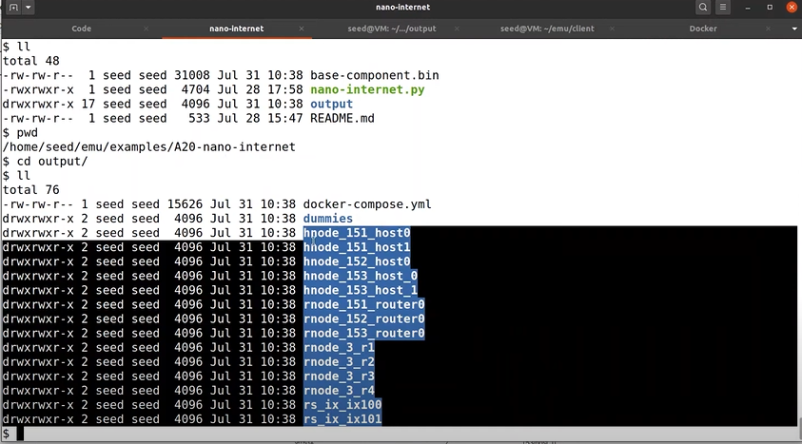

**Visualizing the emulator**

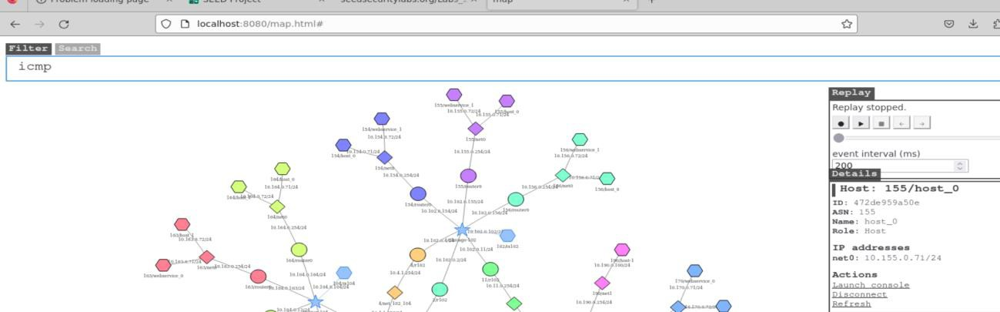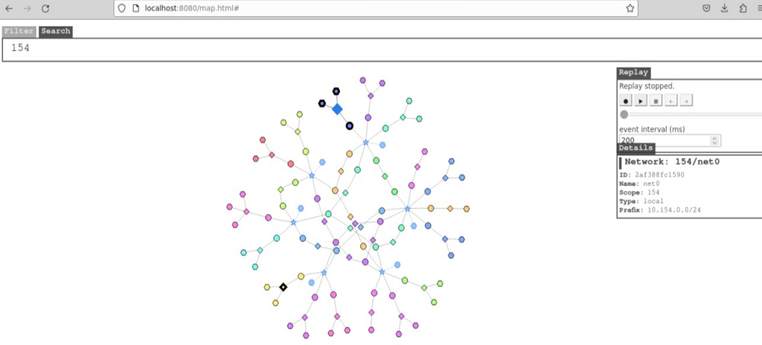





**Visualizing the emulator**





These are list of folders for each docker file





**Visualizing the emulator**



**Adding the layers and rendering**

Once all layers are properly configured, the next step is to add them to the renderer to initiate the emulation. This rendering phase is where the actual setup comes to life:

* Software components are deployed onto the nodes
* Routing tables and network protocols are established
* BGP peerings are configured and activated

The rendering process effectively brings the network emulation to an operational state. Below is an example to illustrate this:

emu.addLayer(base)

emu.addLayer(Routing())

emu.addLayer(ebgp)

emu.addLayer(Ibgp())

emu.addLayer(Ospf())

emu.render()

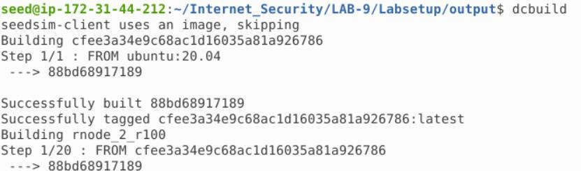

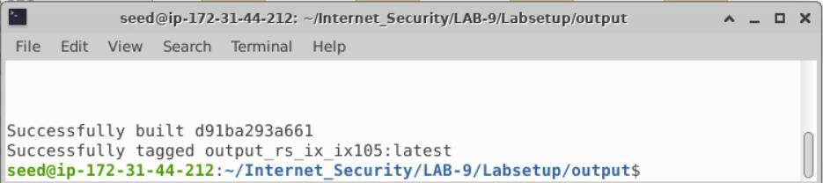

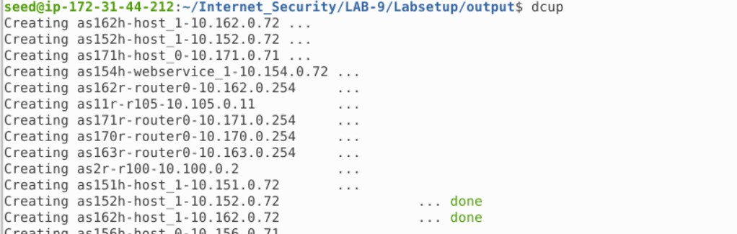

**2nd tab**

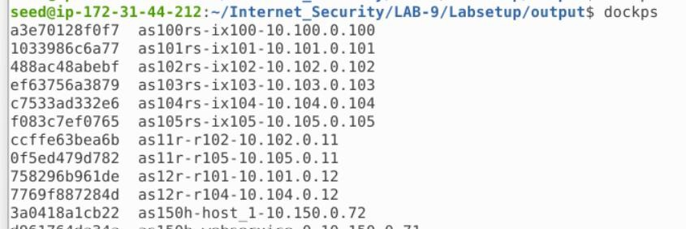

Now let’s open the map http://localhost:8080/map.html

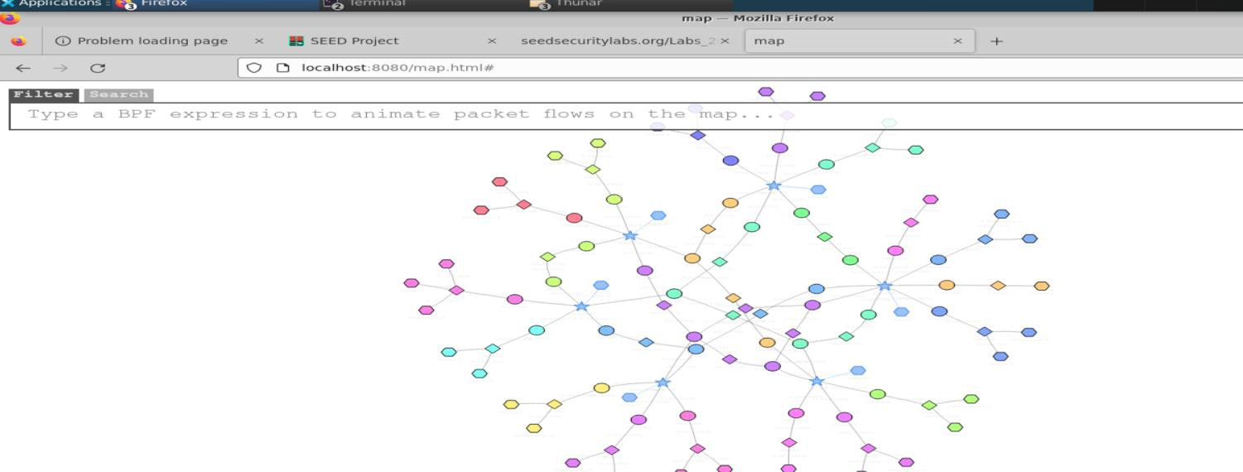

Type 154 on the map

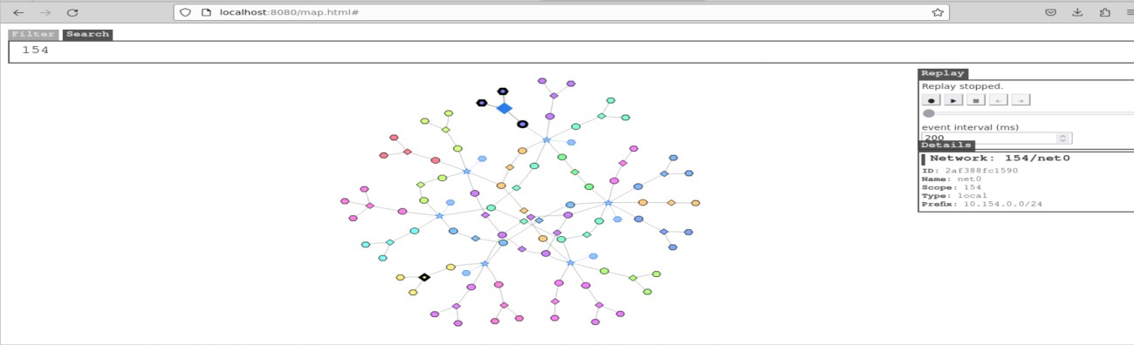

Before we launch the Autonomous system we should be able to access the host The prefix we are going to use is this one

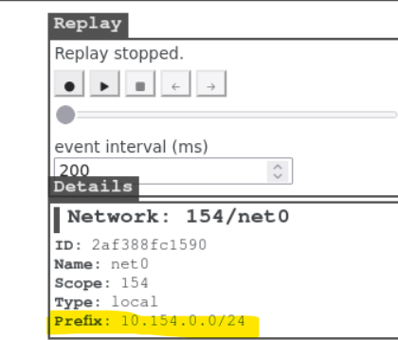

Before we built in we should be able to access this host

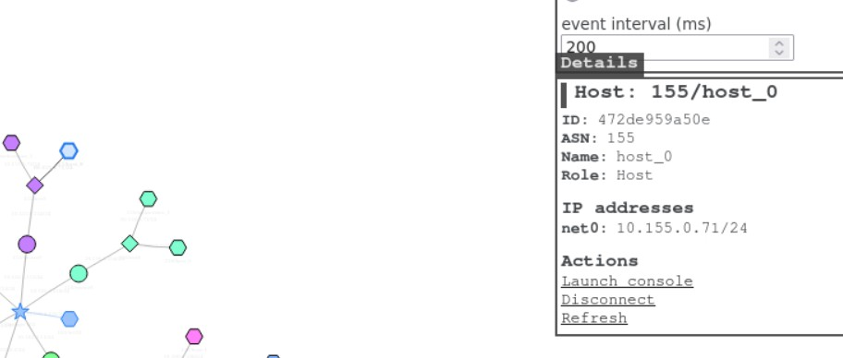

Launch the console

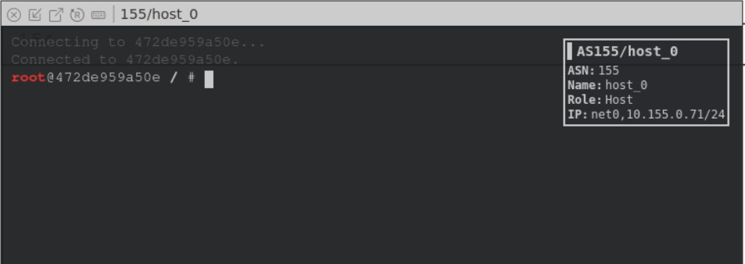

We are able to see its reachable

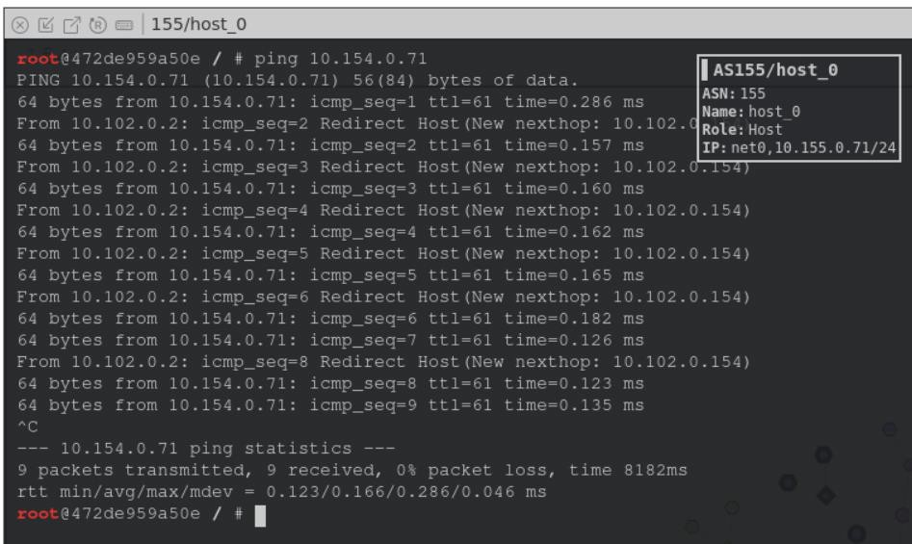

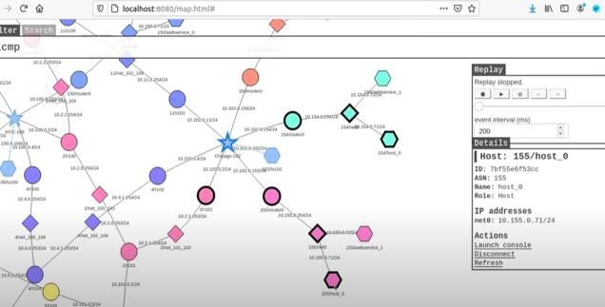



## Task 5.a. Launching the Prefix Hijacking Attack from AS-161

1. Create a static protocol in the attack machine(AS-161)
2. Launch console on As-161

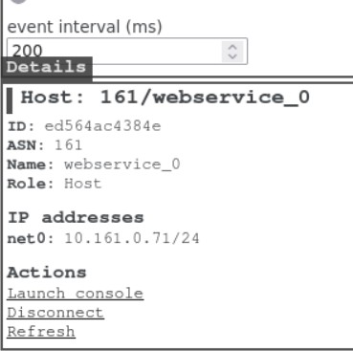

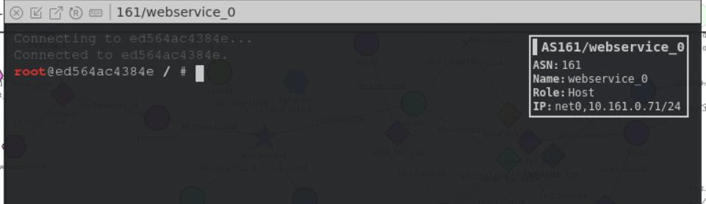

We will see whether we can access 154

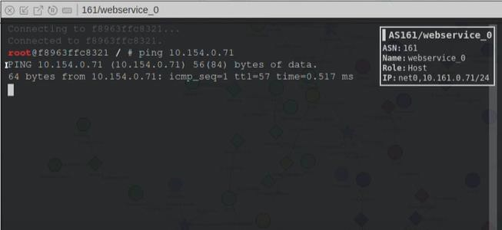

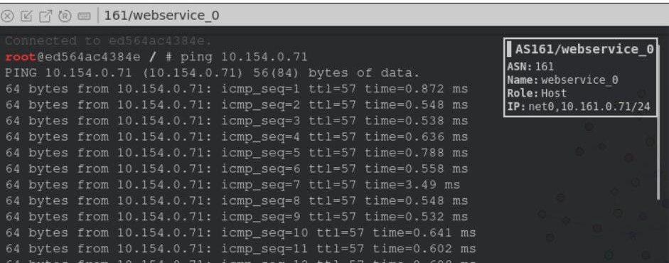

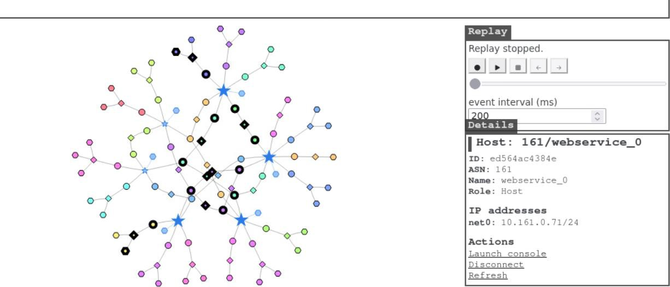

We are now able to access As-154 and AS-161

To announce the attack we need to go inside the BGP-router Go inside BGP router and launch the console

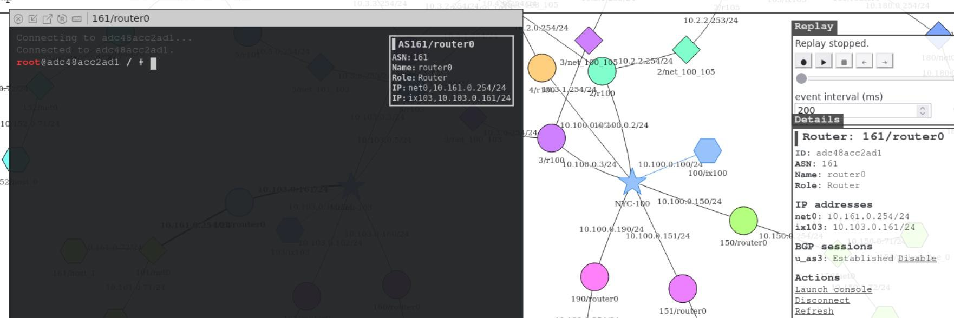

# bird.conf

router id 10.0.0.27; ipv4 table t_direct; protocol device {

}

protocol kernel { ipv4 {

import all; export all;

};

learn;

}

protocol direct local_nets { ipv4 {

table t_direct; import all;

};

interface "net0";

}

define LOCAL_COMM = (161, 0, 0);

define CUSTOMER_COMM = (161, 1, 0);

define PEER_COMM = (161, 2, 0);

define PROVIDER_COMM = (161, 3, 0);

ipv4 table t_bgp; protocol pipe {

table t_bgp;

peer table master4; import none; export all;

}

protocol pipe { table t_direct; peer table t_bgp; import none;

export filter { bgp_large_community.add(LOCAL_COMM); bgp_local_pref = 40; accept; };

}

protocol bgp u_as3 { ipv4 {

table t_bgp; import filter {

bgp_large_community.add(PROVIDER_COMM); bgp_local_pref = 10;

accept;

};

export where bgp_large_community ~ [LOCAL_COMM, CUSTOMER_COMM]; next hop self;

};

local 10.103.0.161 as 161;

neighbor 10.103.0.3 as 3;

}

ipv4 table t_ospf; protocol ospf ospf1 {

ipv4 {

table t_ospf; import all; export all;

};

area 0 {

interface "dummy0" { stub; }; interface "ix103" { stub; };

interface "net0" { hello 1; dead count 2; };

};

}

protocol pipe { table t_ospf;

peer table master4; import none; export all;

}

We can check the bird configuration file by typing the following command.

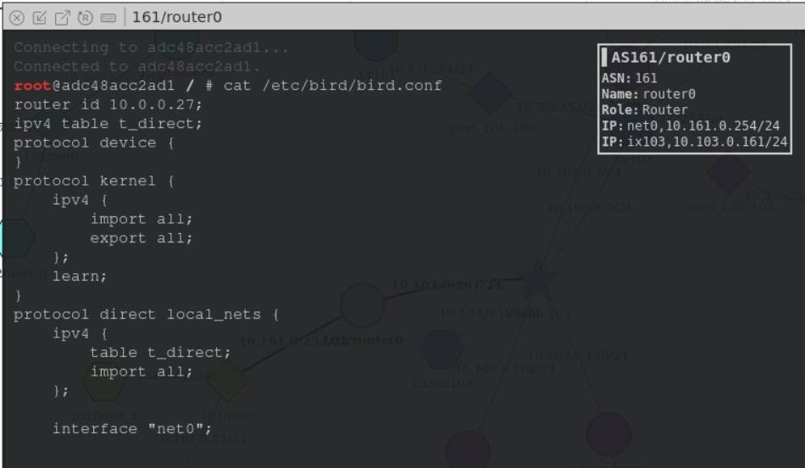

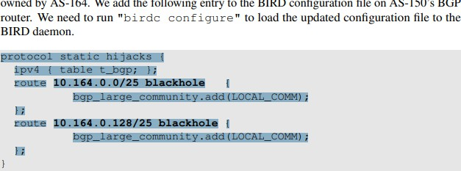

How do we put the below file into the router

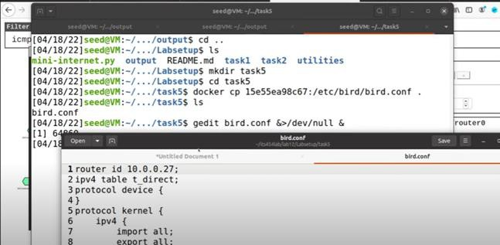

**Open** +

**Int Ir" l**

**bird.cont**

.Al '

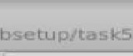

**Save**

1 router id 10.8. 0. 27;

1. ipv4 table t direct;
2. protocol device {
3. }
4. protocol kernel {
5. ipv4 {
6. import all;
7. export all;

9 };

10 learn;

11}

**:f Doc.umEir,t ....** bird.conf

1. protocol direct local nets {
2. ipv4 {
3. tablet direct;
4. import **ill;**

16 };

17

**18** interface "net0";

19

20}

1. define LOCAL COMM = ( 161, 0, 0);
2. define CUSTOMER COMM = ( 161, 1, 8);
3. define PEER COMM = ( 161, 2, 0);
4. define PROVIDER COMM = (161. 3, 8);
5. ipv4 table t bgp;
6. protocol pipe {
7. tablet bgp;
8. peer table master4;
9. **import none:**
10. export all;

31}

32protocol pipe {

1. tablet direct;
2. peer table t_bgp;
3. **import none;**
4. export filter { bQPlarae communitv._add(LOCAL COMM)_; bop 1-ocal pref= 40 acce_pt_; _} ,.

Open  **bird.cont** Save **O**



+ X

)(

fl **t** ·,

De, um nt l bird.cont

34

35

36

37}

peer tab7:e t_bgp; import none;

export filter { bgp_large_community.add(LOCAL_COMM); bgp_local_pref

40; accept; };

1. protocol bgp u as3 {
2. ipv4 { -
3. table t_bgp;
4. import filter {
5. bgp large community.add(PROVIDER COMM);
6. bgp-local-pref = 10; -
7. accept; -

45 };

1. export where bgp_large_community - [LOCAL_COMM, CUSTOMER_COMMJ;
2. next hop self;

48 };

49 local 10.183.0.161 as 161;

50 neighbor 10.103.0.3 as 3;

51}

1. ipv4 table t ospf;
2. protocol ospf ospfl {
3. ipv4 {
4. tablet ospf;
5. import all;
6. export all;

58 };

1. area 0 {
2. interface "dummy0" { stub; };
3. interface "ixl03" { stub; };
4. interface "netO" { hello l; dead count 2; }; 63

64 };

65}

1. protocol pipe {
2. table t ospf;
3. peer table master4;
4. import none;

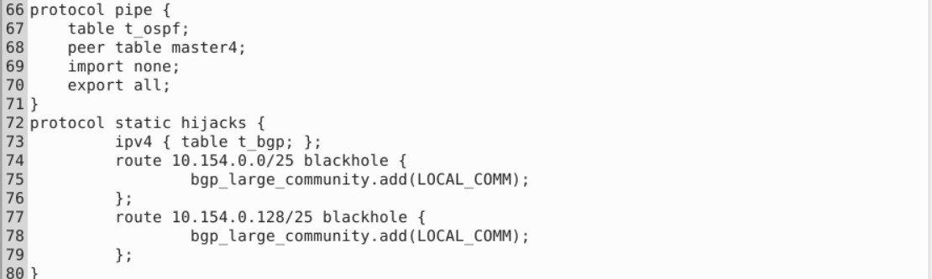

Copy the above file in the router 161

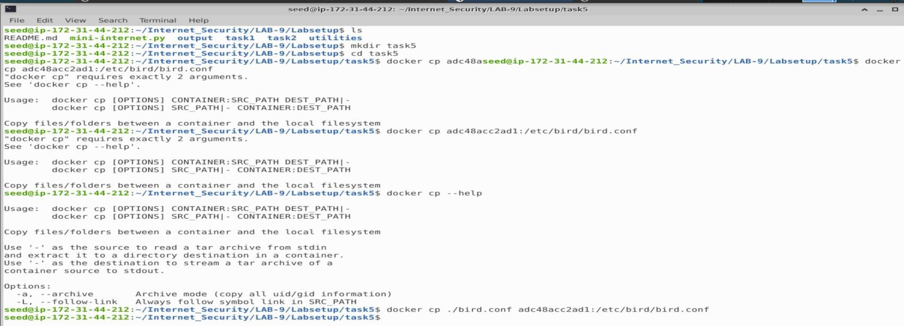

For executing the file in the router

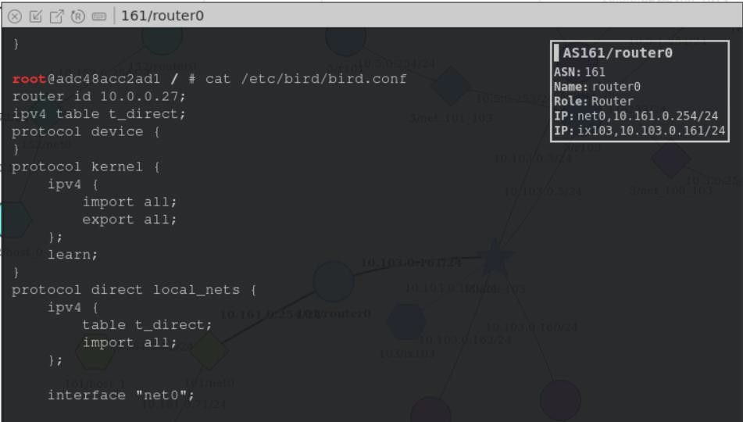

We are able to see static high jacks

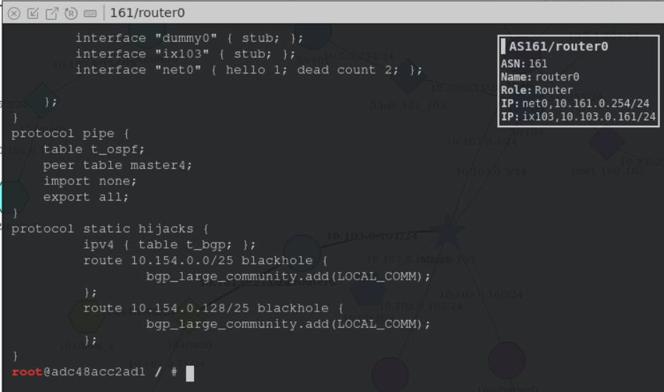

Now we need to reload the configuration

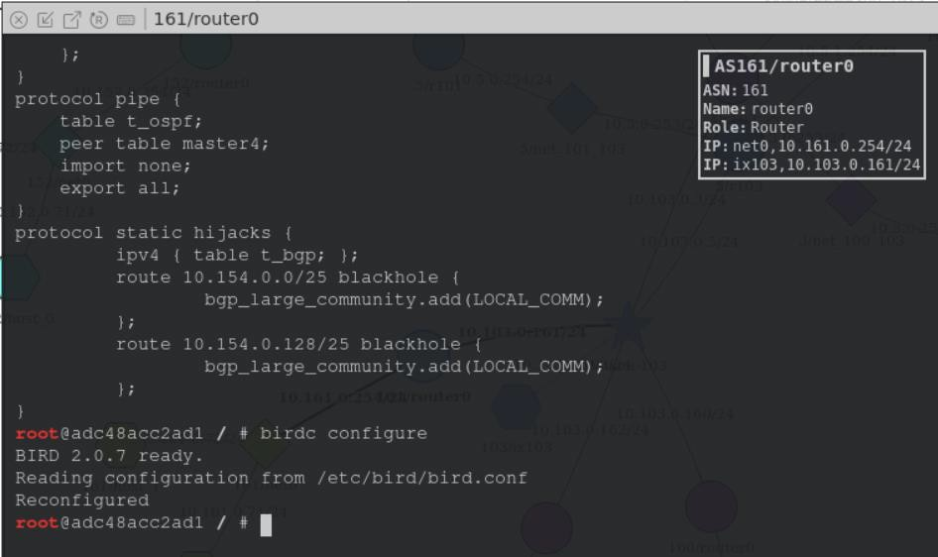

We need to show route all to the victim

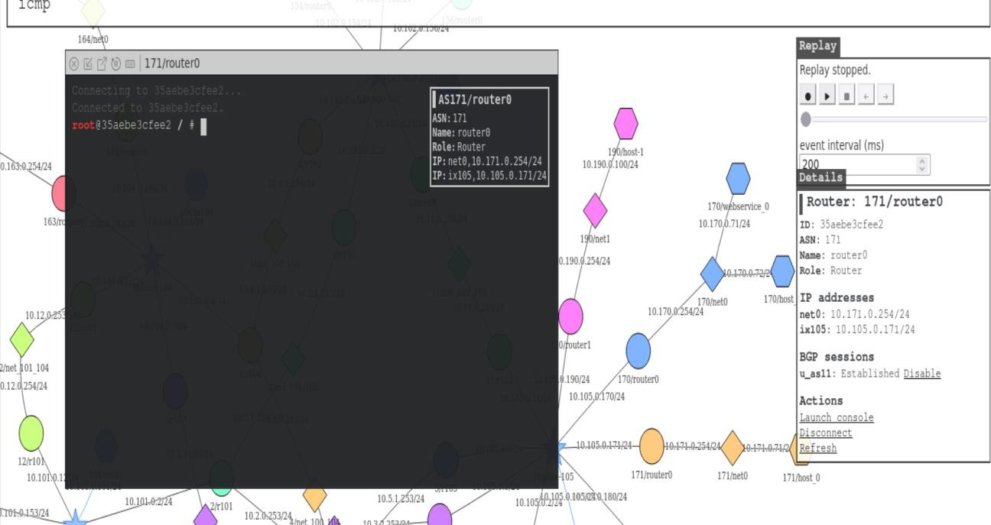

We use birdc show route all to the victim prefix.

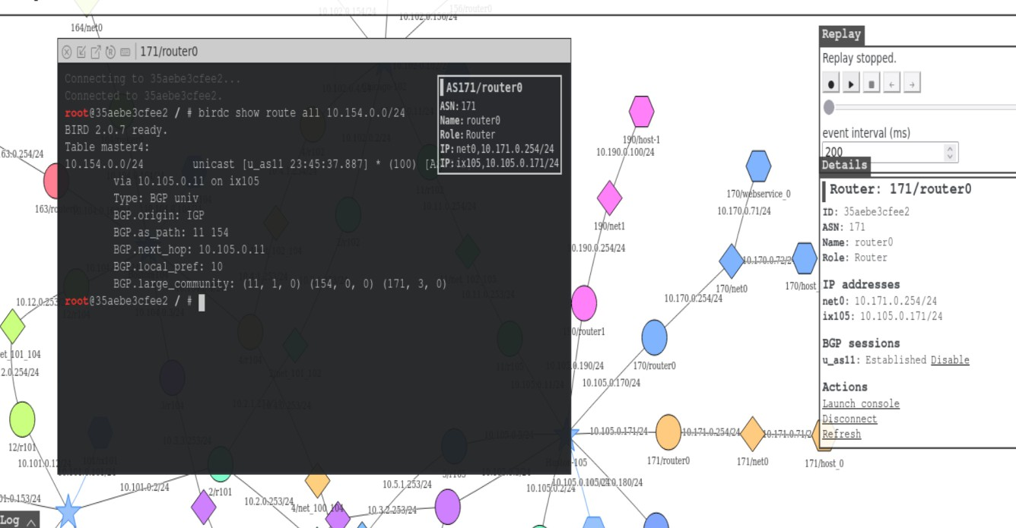

There’s a route announced by As-154

We need to show the attackers advertisement

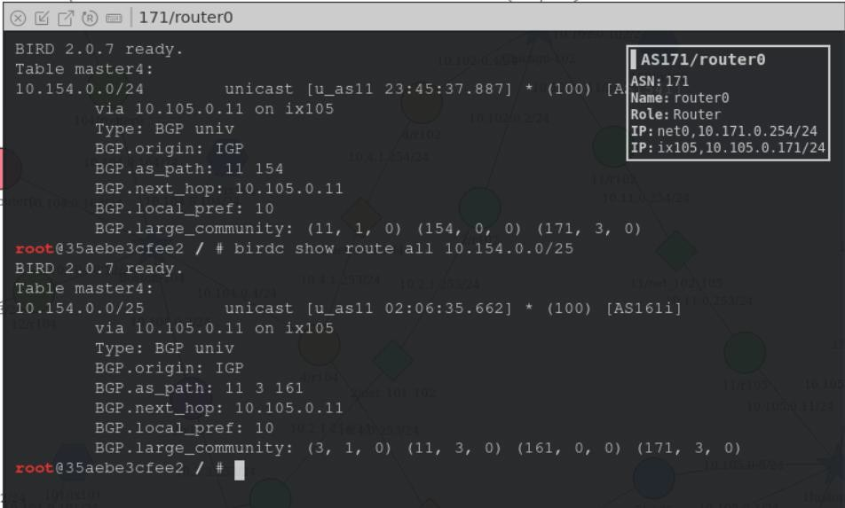

Rerouted to 161 for the 1st half of the address base

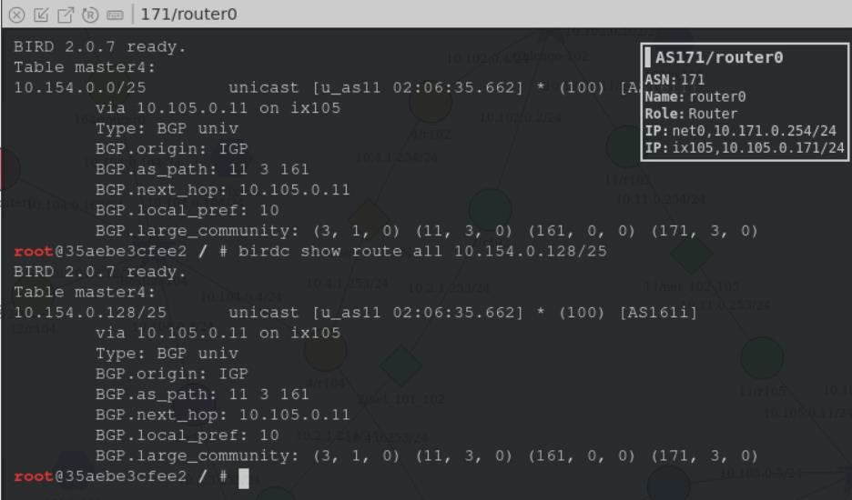

Second half of the address base also rerouted to 161 Before we launch the attack we are able to access 155 We did not get any reply here

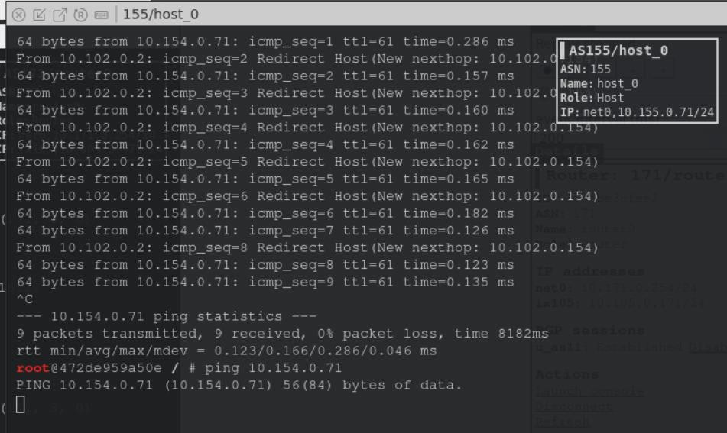

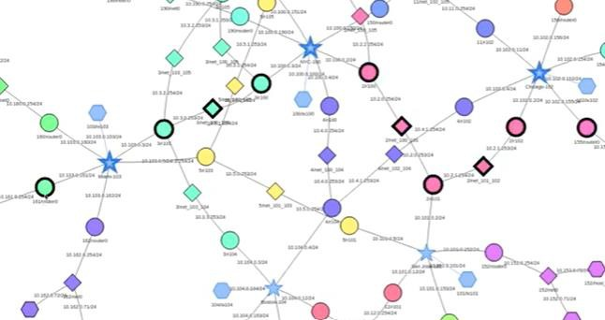

We hijacked 161 and we are unable to access 154 We can check the routes in the kernel routng table

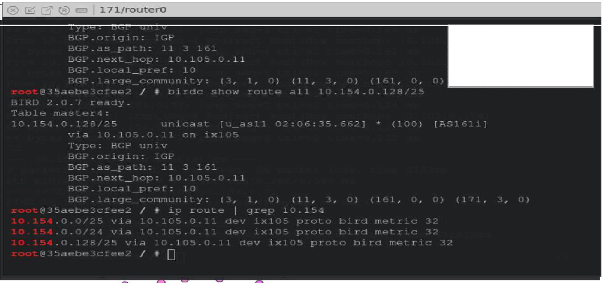

I AS171/router0

-: l

Name - -, , 1

Role: :- ·, •

Ip: 11,_ t - 11._, l *I* l LI - .:, - :

IP 1 • 1 ) - : I : , - *!* 1...., . --1

AStL

@; [j" ® **11/rl0S**

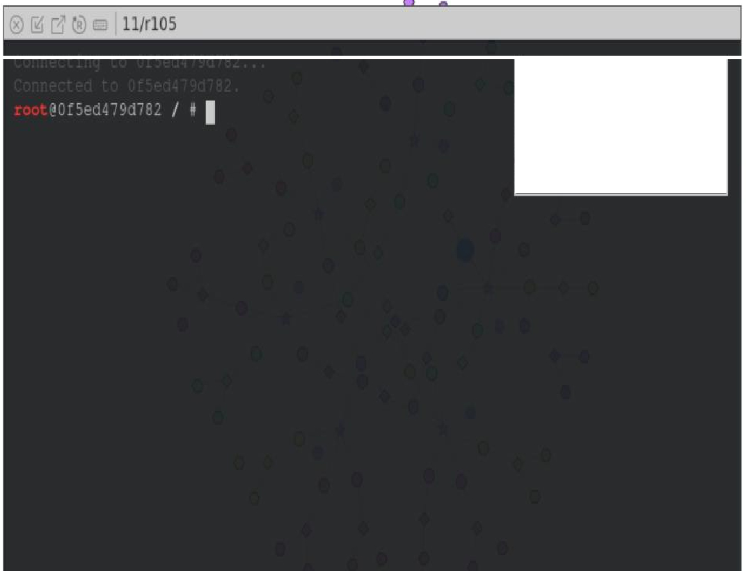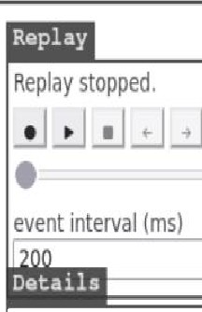

IA5ll/rl05

ASN l

Na11e l

Role 2 ·,

IP , : C 1 1 _..:

IP t. 1 11 J .. .:: _.,

I Router: 11/ rl 05

ID: Of5ed479dl81

ASH: ti

**Name:** r!05

Rola: Router

IP **addrouos**

ix!05: 10.105.0.11/24 net_lD2_!05: 10.11 0.253/24

BGP sassions

**u_as3:** E,tabli,hed

c_asl11: Established Disable

**i.bgpl:** Established

Actions

Launch console

!li..lli!!.!lll

Refresh

_.

*I*

I

I

**Naine**,**:**

**ASll/rlOS**

**ASN:** 11

105

P.;,u:

**Role:**

**IP:** 1dDS, D :os 0.11.'2.:!

**IP::iet**

LO 105,10.11.0.:53/ -l

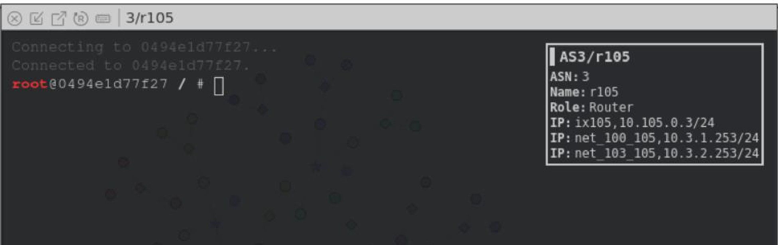

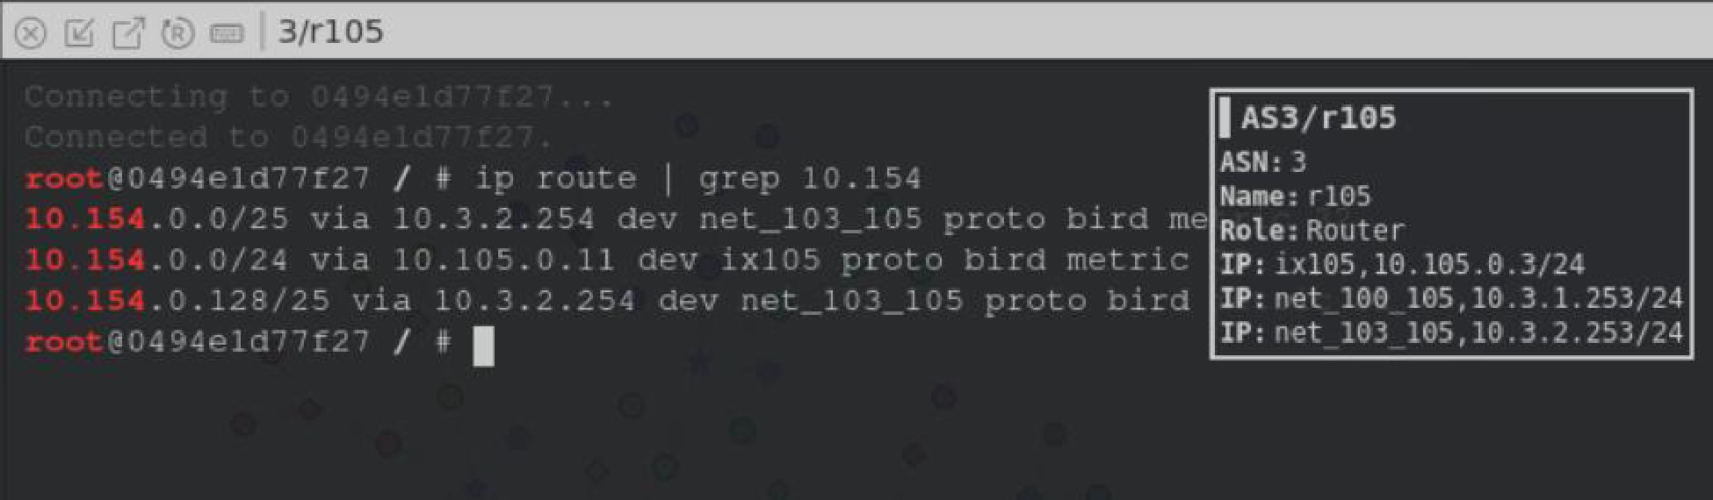

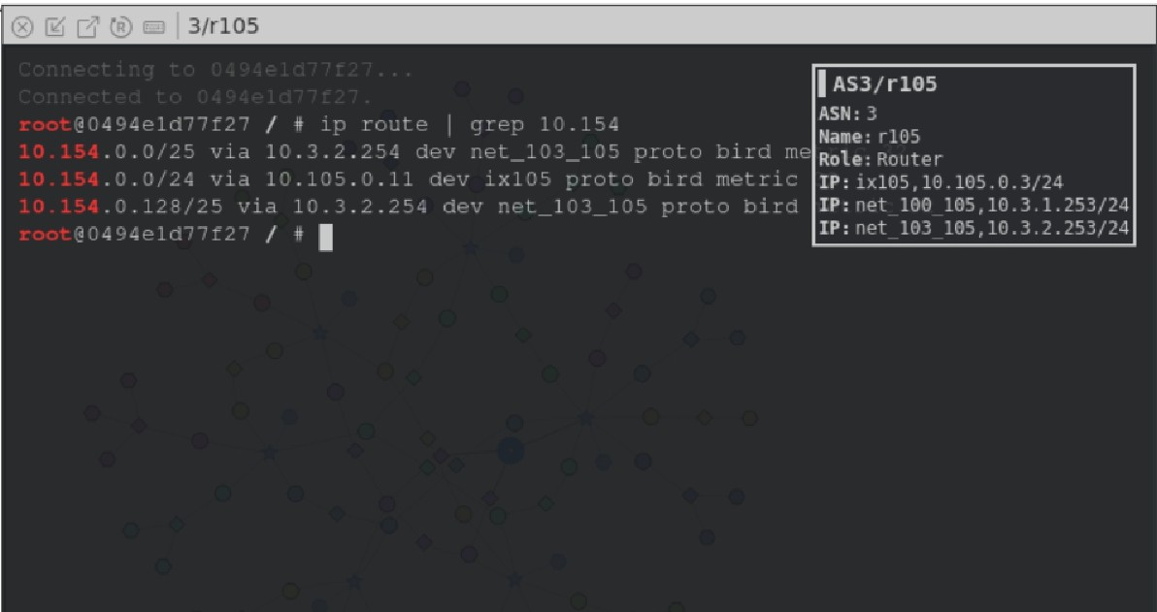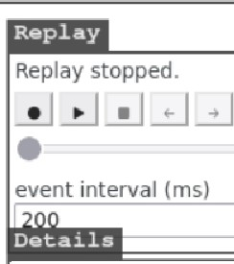

I **Router:** 3/rl05

ID: 0494eldT7f21

ASN: 3

Name: rl05

Rola: Routec-

IP **addresses**

1xl05: 10.105.0.3/24 nat_100_105: 10. 3.1.253/24

net_l03_105: 10. 3. 2. 253/24

BGP !!Uill!!lsiona

p_r■l05; Establi.5hed

- --••. r--... -L-.1,_1,._,.1 ns--L...1-

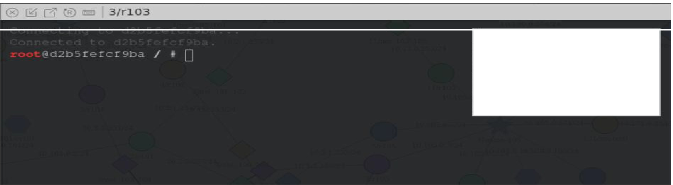

I AS3/rl.03

ASN, Name: 111:::

Ro le. ;::, _, 1• •- 1

IP: _,1n_i l') l _. 1

IP: ,• t - l*=* .:..(..,

IP: •.l .:..u:: :.u

IP: , t . r1 1 _r

t1l

lU

lu

* .>l

) ', , . ..i

_ "'i-t _ -l

::: St _--l

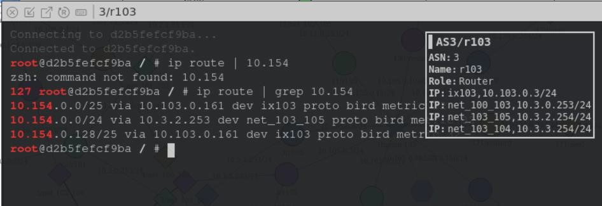

It comes to the attacker router

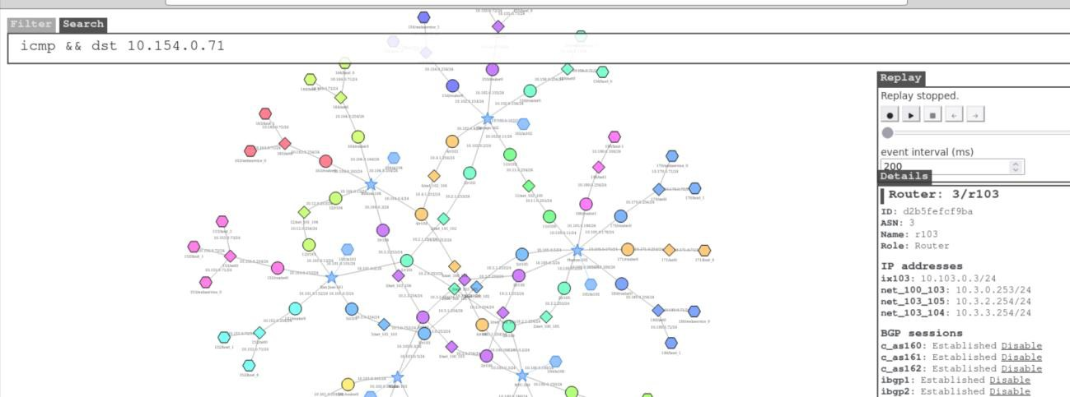

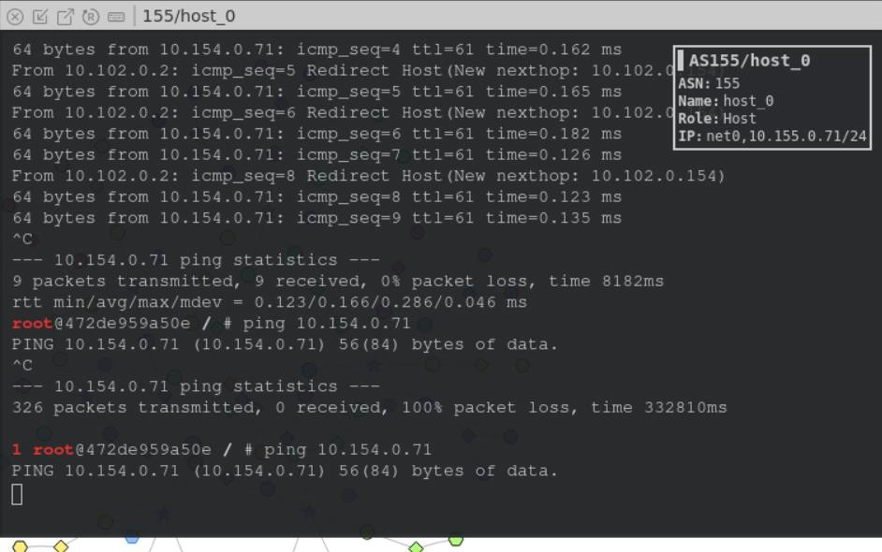

## Task 5.b. Fighting Back from AS-154

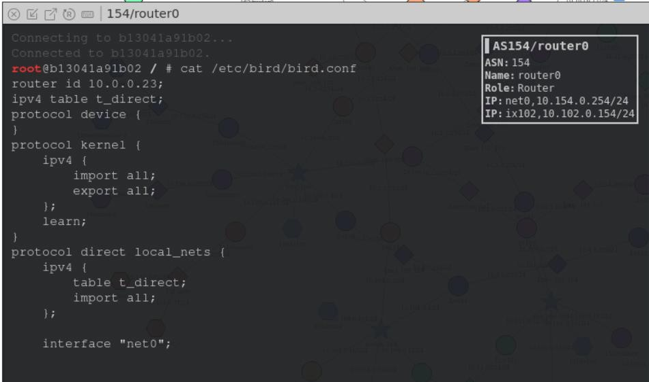

We made the bird154.conf file and executed the file

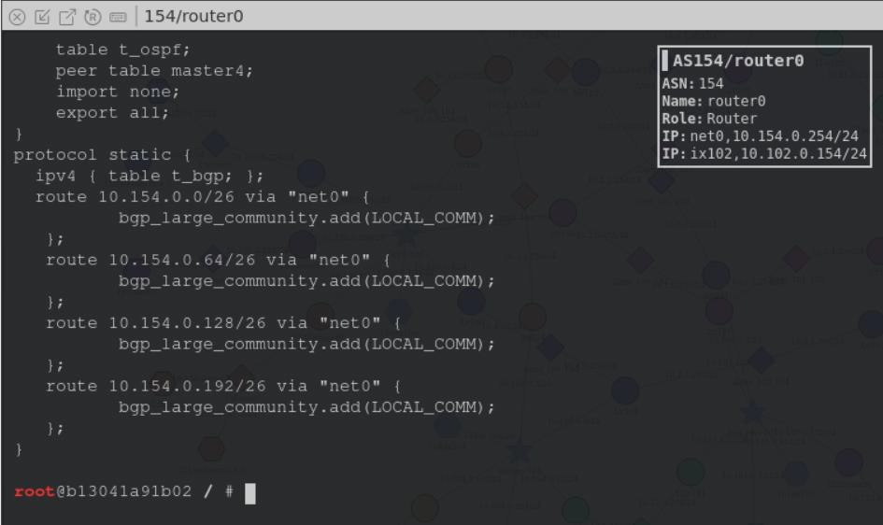

**bird154.conf** router id 10.0.0.23; ipv4 table t_direct; protocol device {

}

protocol kernel { ipv4 {

import all; export all;

};

learn;

}

protocol direct local_nets { ipv4 {

table t_direct; import all;

};

interface "net0";

}

define LOCAL_COMM = (154, 0, 0);

define CUSTOMER_COMM = (154, 1, 0);

define PEER_COMM = (154, 2, 0);

define PROVIDER_COMM = (154, 3, 0);

ipv4 table t_bgp; protocol pipe {

table t_bgp;

peer table master4; import none; export all;

}

protocol pipe { table t_direct; peer table t_bgp; import none;

export filter { bgp_large_community.add(LOCAL_COMM); bgp_local_pref = 40; accept; };

}

protocol bgp u_as2 { ipv4 {

table t_bgp; import filter {

bgp_large_community.add(PROVIDER_COMM); bgp_local_pref = 10;

accept;

};

export where bgp_large_community ~ [LOCAL_COMM, CUSTOMER_COMM]; next hop self;

};

local 10.102.0.154 as 154;

neighbor 10.102.0.2 as 2;

}

protocol bgp u_as4 { ipv4 {

table t_bgp; import filter {

bgp_large_community.add(PROVIDER_COMM); bgp_local_pref = 10;

accept;

};

export where bgp_large_community ~ [LOCAL_COMM, CUSTOMER_COMM]; next hop self;

};

local 10.102.0.154 as 154;

neighbor 10.102.0.4 as 4;

}

protocol bgp u_as11 { ipv4 {

table t_bgp; import filter {

bgp_large_community.add(PROVIDER_COMM); bgp_local_pref = 10;

accept;

};

export where bgp_large_community ~ [LOCAL_COMM, CUSTOMER_COMM]; next hop self;

};

local 10.102.0.154 as 154;

neighbor 10.102.0.11 as 11;

}

ipv4 table t_ospf; protocol ospf ospf1 {

ipv4 {

table t_ospf; import all; export all;

};

area 0 {

interface "dummy0" { stub; }; interface "ix102" { stub; };

interface "net0" { hello 1; dead count 2; };

};

}

protocol pipe { table t_ospf;

peer table master4; import none; export all;

}

protocol static {

ipv4 { table t_bgp; };

route 10.154.0.0/26 via "net0" { bgp_large_community.add(LOCAL_COMM);

};

route 10.154.0.64/26 via "net0" { bgp_large_community.add(LOCAL_COMM);

};

route 10.154.0.128/26 via "net0" { bgp_large_community.add(LOCAL_COMM);

};

route 10.154.0.192/26 via "net0" { bgp_large_community.add(LOCAL_COMM);

};

}

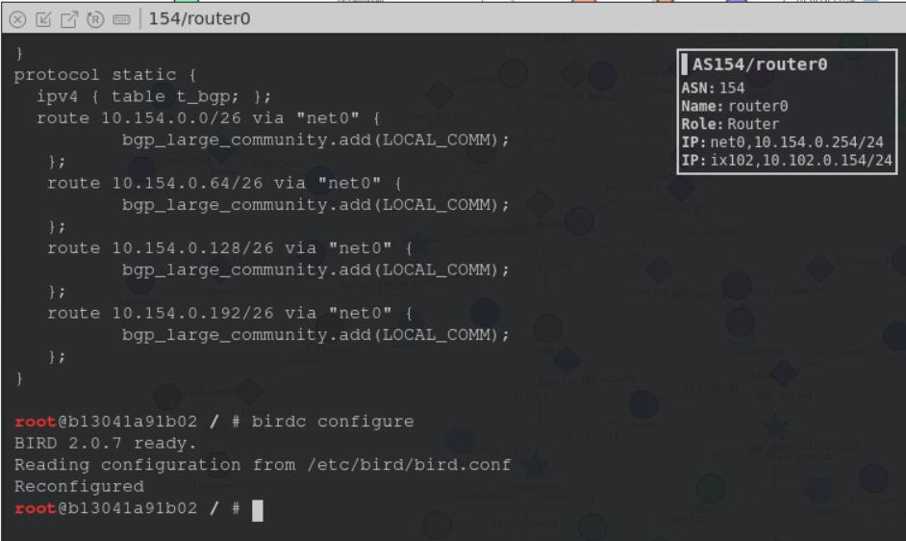

Go to other routers to check the route

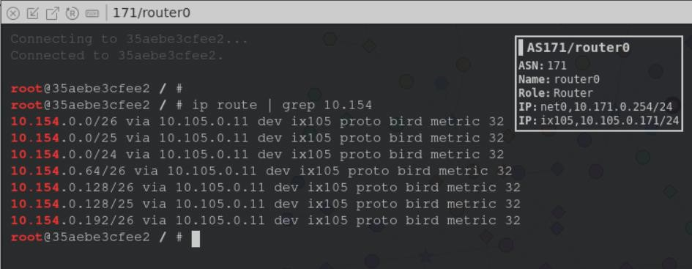

Need to check whether we can access the host.

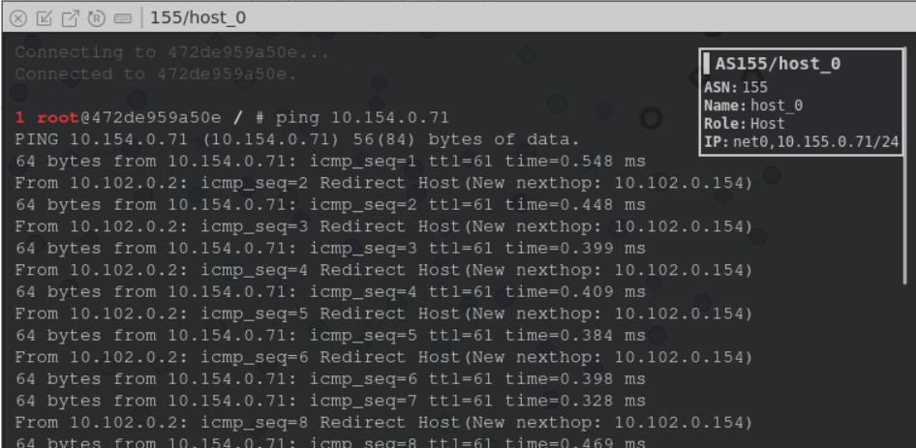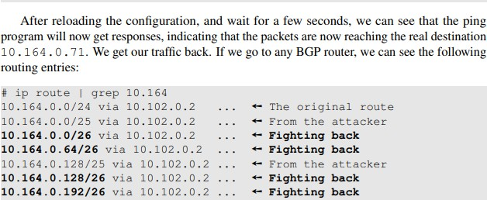

## Task 5.c. Fixing the Problem at AS-3

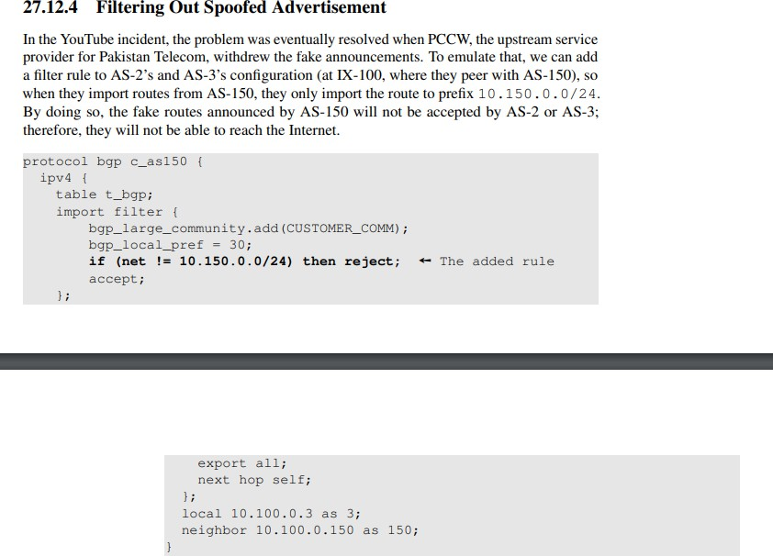

Used by service provider who is AS3

## Modified bird154.conf

router id 10.0.0.23; ipv4 table t_direct; protocol device {

}

protocol kernel { ipv4 {

import all; export all;

};

learn;

}

protocol direct local_nets { ipv4 {

table t_direct; import all;

};

interface "net0";

}

define LOCAL_COMM = (154, 0, 0);

define CUSTOMER_COMM = (154, 1, 0);

define PEER_COMM = (154, 2, 0);

define PROVIDER_COMM = (154, 3, 0);

ipv4 table t_bgp; protocol pipe {

table t_bgp;

peer table master4; import none; export all;

}

protocol pipe { table t_direct; peer table t_bgp; import none;

export filter { bgp_large_community.add(LOCAL_COMM); bgp_local_pref = 40; accept; };

}

protocol bgp u_as2 { ipv4 {

table t_bgp; import filter {

bgp_large_community.add(PROVIDER_COMM); bgp_local_pref = 10;

accept;

};

export where bgp_large_community ~ [LOCAL_COMM, CUSTOMER_COMM]; next hop self;

};

local 10.102.0.154 as 154;

neighbor 10.102.0.2 as 2;

}

protocol bgp u_as4 { ipv4 {

table t_bgp; import filter {

bgp_large_community.add(PROVIDER_COMM); bgp_local_pref = 10;

accept;

};

export where bgp_large_community ~ [LOCAL_COMM, CUSTOMER_COMM]; next hop self;

};

local 10.102.0.154 as 154;

neighbor 10.102.0.4 as 4;

}

protocol bgp u_as11 { ipv4 {

table t_bgp; import filter {

bgp_large_community.add(PROVIDER_COMM); bgp_local_pref = 10;

accept;

};

export where bgp_large_community ~ [LOCAL_COMM, CUSTOMER_COMM]; next hop self;

};

local 10.102.0.154 as 154;

neighbor 10.102.0.11 as 11;

}

ipv4 table t_ospf; protocol ospf ospf1 {

ipv4 {

table t_ospf; import all; export all;

};

area 0 {

interface "dummy0" { stub; }; interface "ix102" { stub; };

interface "net0" { hello 1; dead count 2; };

};

}

protocol pipe { table t_ospf;

peer table master4; import none; export all;

}

/*

protocol static {

ipv4 { table t_bgp; };

route 10.154.0.0/26 via "net0" { bgp_large_community.add(LOCAL_COMM);

};

route 10.154.0.64/26 via "net0" { bgp_large_community.add(LOCAL_COMM);

};

route 10.154.0.128/26 via "net0" { bgp_large_community.add(LOCAL_COMM);

};

route 10.154.0.192/26 via "net0" {

bgp_large_community.add(LOCAL_COMM);

};

}

*/

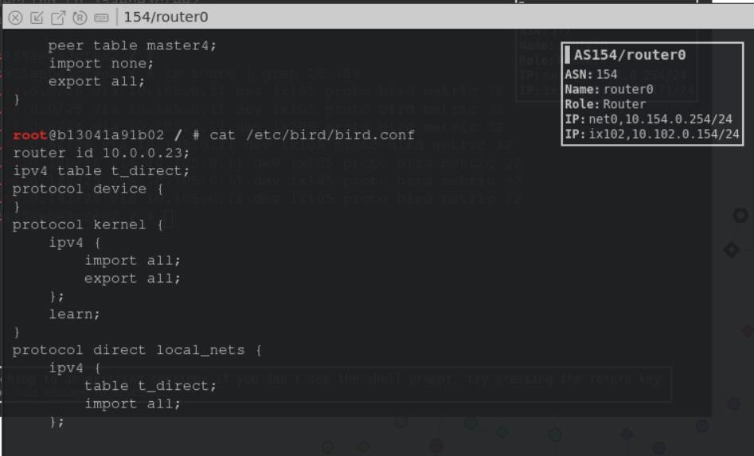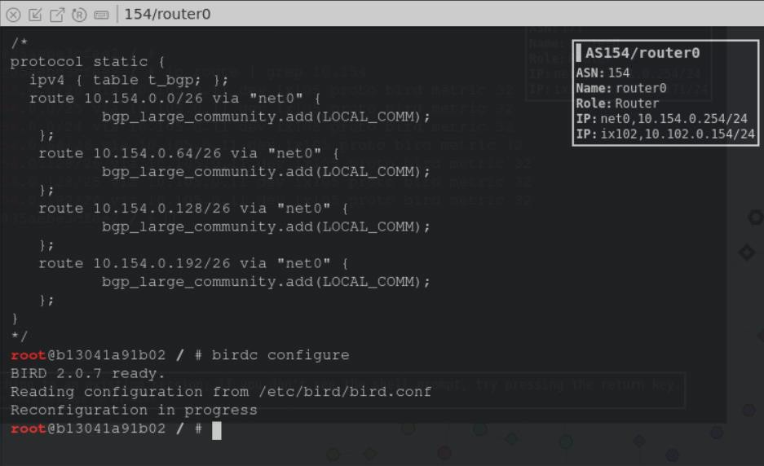

Need to check at another router

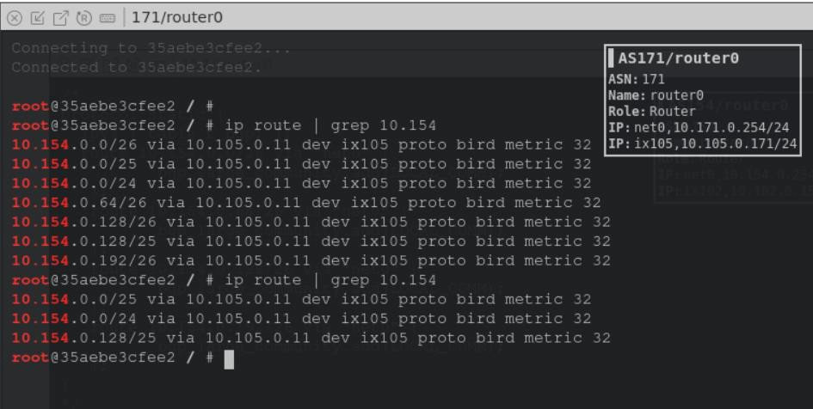

There is no fighting back means As-154 is highjacked by As-161

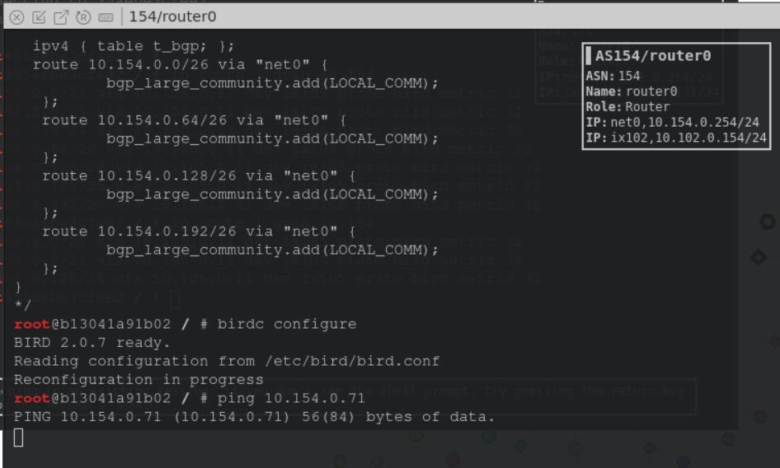

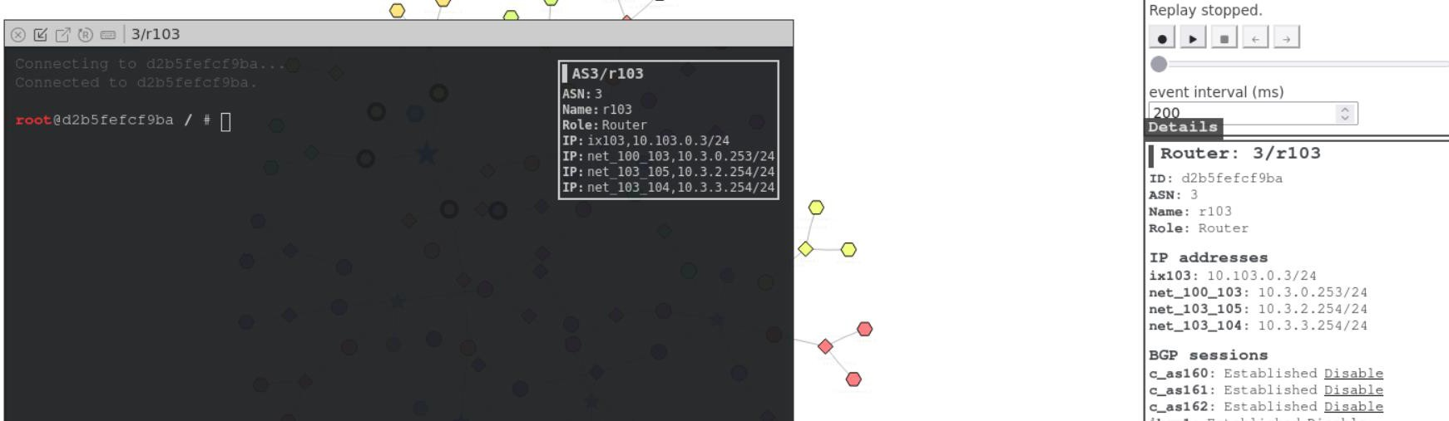

router id 10.0.0.6; ipv4 table t_direct; protocol device {

}

protocol kernel { ipv4 {

import all; export all;

};

learn;

}

protocol direct local_nets { ipv4 {

table t_direct; import all;

};

interface "net_100_103"; interface "net_103_105"; interface "net_103_104";

}

define LOCAL_COMM = (3, 0, 0);

define CUSTOMER_COMM = (3, 1, 0);

define PEER_COMM = (3, 2, 0);

define PROVIDER_COMM = (3, 3, 0);

ipv4 table t_bgp; protocol pipe {

table t_bgp;

peer table master4; import none; export all;

}

protocol pipe { table t_direct; peer table t_bgp; import none;

export filter { bgp_large_community.add(LOCAL_COMM); bgp_local_pref = 40; accept; };

}

protocol bgp c_as160 { ipv4 {

table t_bgp; import filter {

bgp_large_community.add(CUSTOMER_COMM); bgp_local_pref = 30;

accept;

};

export all; next hop self;

};

local 10.103.0.3 as 3;

neighbor 10.103.0.160 as 160;

}

protocol bgp c_as161 { ipv4 {

table t_bgp; import filter {

bgp_large_community.add(CUSTOMER_COMM); bgp_local_pref = 30;

accept;

};

export all; next hop self;

};

local 10.103.0.3 as 3;

neighbor 10.103.0.161 as 161;

}

protocol bgp c_as162 { ipv4 {

table t_bgp; import filter {

bgp_large_community.add(CUSTOMER_COMM); bgp_local_pref = 30;

accept;

};

export all; next hop self;

};

local 10.103.0.3 as 3;

neighbor 10.103.0.162 as 162;

}

ipv4 table t_ospf; protocol ospf ospf1 {

ipv4 {

table t_ospf; import all; export all;

};

area 0 {

interface "dummy0" { stub; }; interface "ix103" { stub; };

interface "net_100_103" { hello 1; dead count 2; }; interface "net_103_105" { hello 1; dead count 2; }; interface "net_103_104" { hello 1; dead count 2; };

};

}

protocol pipe { table t_ospf;

peer table master4; import none; export all;

}

protocol bgp ibgp1 { ipv4 {

table t_bgp; import all; export all;

igp table t_ospf;

};

local 10.0.0.6 as 3;

neighbor 10.0.0.5 as 3;

}

protocol bgp ibgp2 { ipv4 {

table t_bgp; import all; export all;

igp table t_ospf;

};

local 10.0.0.6 as 3;

neighbor 10.0.0.8 as 3;

}

protocol bgp ibgp3 {

ipv4 {

table t_bgp; import all; export all;

igp table t_ospf;

};

local 10.0.0.6 as 3;

neighbor 10.0.0.7 as 3;

}

**bird3.conf**

router id 10.0.0.6; ipv4 table t_direct; protocol device {

}

protocol kernel { ipv4 {

import all; export all;

};

learn;

}

protocol direct local_nets { ipv4 {

table t_direct; import all;

};

interface "net_100_103"; interface "net_103_105"; interface "net_103_104";

}

define LOCAL_COMM = (3, 0, 0);

define CUSTOMER_COMM = (3, 1, 0);

define PEER_COMM = (3, 2, 0);

define PROVIDER_COMM = (3, 3, 0);

ipv4 table t_bgp; protocol pipe {

table t_bgp;

peer table master4; import none; export all;

}

protocol pipe { table t_direct; peer table t_bgp; import none;

export filter { bgp_large_community.add(LOCAL_COMM); bgp_local_pref = 40; accept; };

}

protocol bgp c_as160 { ipv4 {

table t_bgp; import filter {

bgp_large_community.add(CUSTOMER_COMM); bgp_local_pref = 30;

accept;

};

export all; next hop self;

};

local 10.103.0.3 as 3;

neighbor 10.103.0.160 as 160;

}

protocol bgp c_as161 { ipv4 {

table t_bgp; import filter {

bgp_large_community.add(CUSTOMER_COMM); bgp_local_pref = 30;

if (net != 10.154.0.0/24) then reject; accept;

};

export all; next hop self;

};

local 10.103.0.3 as 3;

neighbor 10.103.0.161 as 161;

}

protocol bgp c_as162 { ipv4 {

table t_bgp; import filter {

bgp_large_community.add(CUSTOMER_COMM); bgp_local_pref = 30;

accept;

};

export all; next hop self;

};

local 10.103.0.3 as 3;

neighbor 10.103.0.162 as 162;

}

ipv4 table t_ospf; protocol ospf ospf1 {

ipv4 {

table t_ospf; import all; export all;

};

area 0 {

interface "dummy0" { stub; }; interface "ix103" { stub; };

interface "net_100_103" { hello 1; dead count 2; }; interface "net_103_105" { hello 1; dead count 2; }; interface "net_103_104" { hello 1; dead count 2; };

};

}

protocol pipe { table t_ospf;

peer table master4; import none; export all;

}

protocol bgp ibgp1 { ipv4 {

table t_bgp; import all; export all;

igp table t_ospf;

};

local 10.0.0.6 as 3;

neighbor 10.0.0.5 as 3;

}

protocol bgp ibgp2 { ipv4 {

table t_bgp; import all; export all;

igp table t_ospf;

};

local 10.0.0.6 as 3;

neighbor 10.0.0.8 as 3;

}

protocol bgp ibgp3 {

ipv4 {

table t_bgp; import all; export all;

igp table t_ospf;

};

local 10.0.0.6 as 3;

neighbor 10.0.0.7 as 3;

}

We need to change the victim it is 154

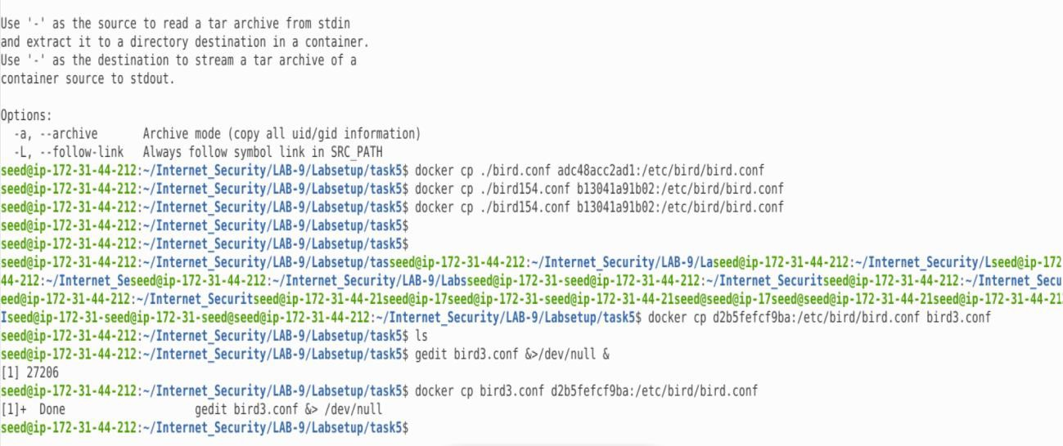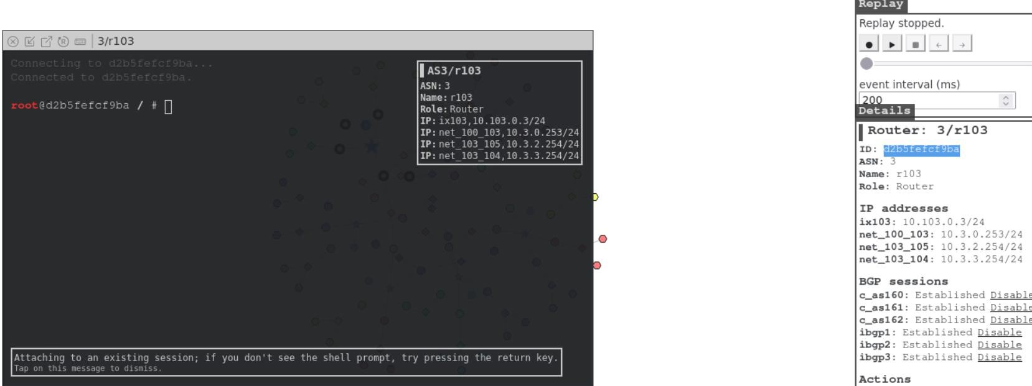

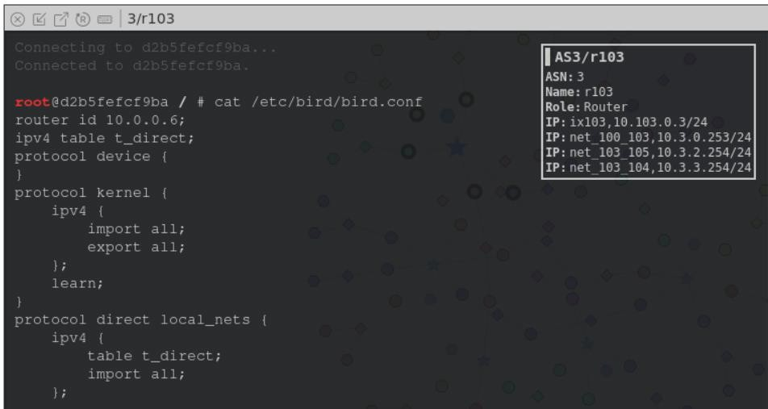

root@d2b5fefcf9ba / # cat /etc/bird/bird.conf router id 10.0.0.6;

ipv4 table t_direct; protocol device {

}

protocol kernel { ipv4 {

import all; export all;

};

learn;

}

protocol direct local_nets { ipv4 {

table t_direct; import all;

};

interface "net_100_103"; interface "net_103_105"; interface "net_103_104";

}

define LOCAL_COMM = (3, 0, 0);

define CUSTOMER_COMM = (3, 1, 0);

define PEER_COMM = (3, 2, 0);

define PROVIDER_COMM = (3, 3, 0);

ipv4 table t_bgp; protocol pipe {

table t_bgp;

peer table master4; import none; export all;

}

protocol pipe { table t_direct; peer table t_bgp; import none;

export filter { bgp_large_community.add(LOCAL_COMM); bgp_local_pref = 40; accept; };

}

protocol bgp c_as160 { ipv4 {

table t_bgp; import filter {

bgp_large_community.add(CUSTOMER_COMM); bgp_local_pref = 30;

accept;

};

export all; next hop self;

};

local 10.103.0.3 as 3;

neighbor 10.103.0.160 as 160;

}

protocol bgp c_as161 { ipv4 {

table t_bgp; import filter {

bgp_large_community.add(CUSTOMER_COMM); bgp_local_pref = 30;

if (net != 10.161.0.0/24) then reject; accept;

};

export all; next hop self;

};

local 10.103.0.3 as 3;

neighbor 10.103.0.161 as 161;

}

protocol bgp c_as162 { ipv4 {

table t_bgp; import filter {

bgp_large_community.add(CUSTOMER_COMM); bgp_local_pref = 30;

accept;

};

export all; next hop self;

};

local 10.103.0.3 as 3;

neighbor 10.103.0.162 as 162;

}

ipv4 table t_ospf; protocol ospf ospf1 {

ipv4 {

table t_ospf; import all; export all;

};

area 0 {

interface "dummy0" { stub; }; interface "ix103" { stub; };

interface "net_100_103" { hello 1; dead count 2; }; interface "net_103_105" { hello 1; dead count 2; }; interface "net_103_104" { hello 1; dead count 2; };

};

}

protocol pipe { table t_ospf;

peer table master4; import none; export all;

}

protocol bgp ibgp1 { ipv4 {

table t_bgp; import all; export all;

igp table t_ospf;

};

local 10.0.0.6 as 3;

neighbor 10.0.0.5 as 3;

}

protocol bgp ibgp2 { ipv4 {

table t_bgp; import all; export all;

igp table t_ospf;

};

local 10.0.0.6 as 3;

neighbor 10.0.0.8 as 3;

}

protocol bgp ibgp3 { ipv4 {

table t_bgp; import all; export all;

igp table t_ospf;

};

local 10.0.0.6 as 3;

neighbor 10.0.0.7 as 3;

}

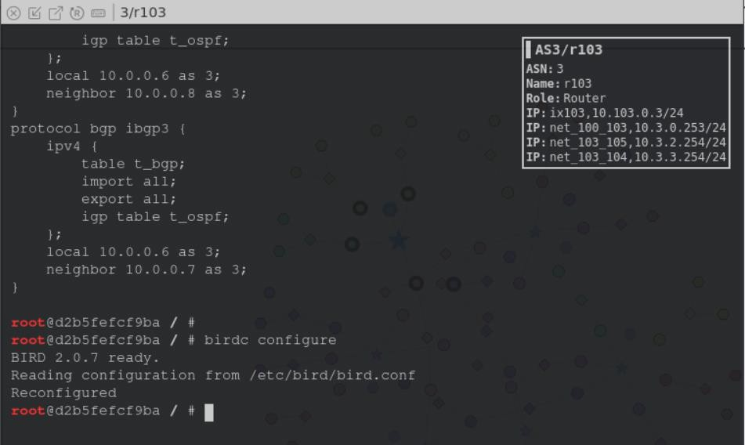

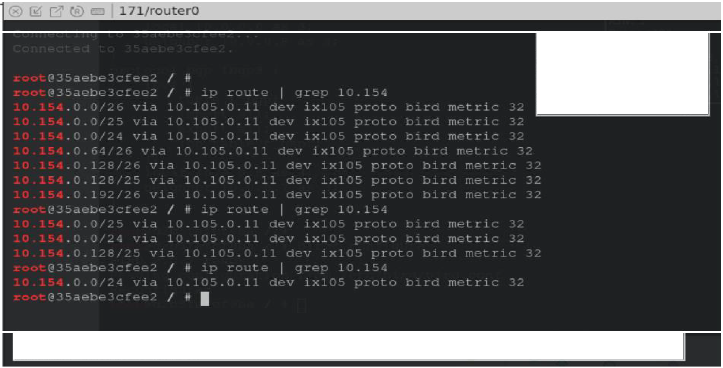

I **AS171/routero**

**A5'J:** l'

**Name:** _, t _, 1_1

**Role** =-111 1- •

**IP.** • ':, J, : I U .' -l .·

IP:1,1:,=1,··=:,17· .J

At .. ,11! 1•111 t,1 1r i _•,t1: •, ,·,11111, 1t y<Jll •l r, t '''f' ti,• •,l•ll t1l<d1fJt, .. ,y ••r•• ,.·q I'•• r1f11r11 ,.,

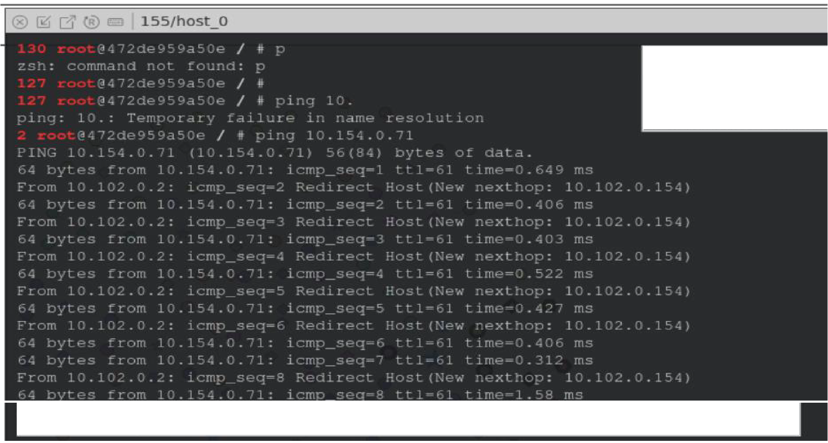

I **AS155/host_O**

**ASN:** :ss

**Name:** 1,, , **t** ll

**Role:H,** ,t

IP:r etO, 10 l:,':, O. /L --l

.,.,:.5s1nn, 1t :,)IJ f1::>n't C•t".°I th,:. r:;t-0ll prcr:-1r1t, try ;----nc:..,.,:, t>- , r,-=-t1Jr-n *J,,.,-=-1*

At .. ,-1cl-1ng to r ,- :.(:s l ]

; '

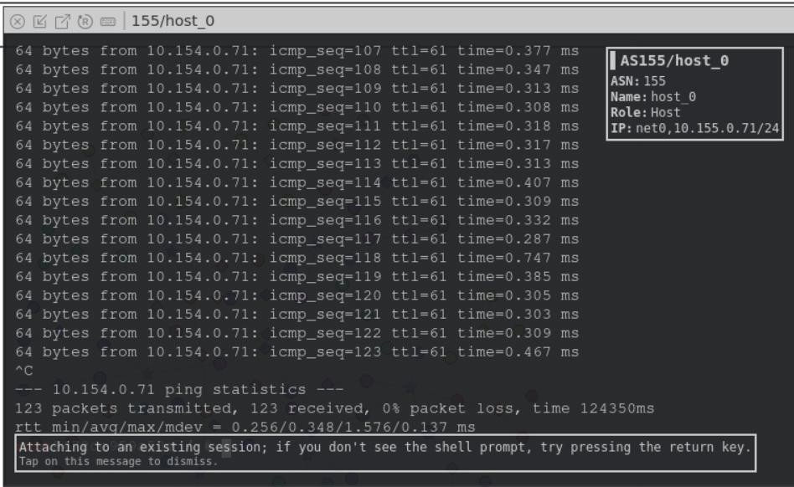

2nd way is the service provider to stop the autonomous system and not fake